Asymmetric DCC correlation: EURUSD and USDCAD
Method 10 / GARCH(1,1) + Cappiello-Engle-Sheppard ADCC / Alpari D1 full available history

Study setup
Logical pair: EURUSD , USDCAD
Broker symbols: EURUSD_i , USDCAD_i
Snapshot: 2026-11-03_majors_alpari_D1
Timeframe: D1
Matched return window: 1999-01-05 to 2026-11-02 (UTC bar dates)
Matched return count n: 7188
Dropped unfinished last bar dated 2026-11-03 UTC after a tick-volume check against the prior complete day.
EURUSD GARCH(1,1): mu=0.000008, omega=0.001158, alpha=0.036776, beta=0.959919
USDCAD GARCH(1,1): mu=-0.000007, omega=0.001261, alpha=0.043698, beta=0.951141
ADCC: a=0.020367, b=0.976171, g=0.000000, a+b+g/2=0.996537
Nested DCC (g=0): a=0.020367, b=0.976171
Negative shock: n = min(z, 0) in broker quote direction (not inverted)
Burn-in ignored in path summaries and chart: first 60 updates
Complete matched rows (Excel): EURUSD-USDCAD_ADCC_D1.xlsx
Complete matched rows (HTML table): EURUSD-USDCAD_ADCC_D1_data.html

Method carried forward
Asymmetric DCC extends Engle DCC with an extra term on joint negative standardised shocks. Each matched daily log return of close, ln(close_t / close_t-1), is first filtered by a constant-mean GARCH(1,1). Then z = residual / sigma and n = min(z, 0). The Cappiello-Engle-Sheppard recursion uses A = (1-a-b) Q_bar - g N_bar with N_bar = mean(n n'). Quotes are not inverted, so a negative shock is a negative log return in the broker quote. Nested symmetric DCC (g = 0) is fit on the same z path for comparison. Constraints: a,b,g >= 0 and a + b + g/2 < 1. Path summaries ignore the first 60 updates. The headline is latest ADCC rho. Pearson r is a side check only. This is not a cause, lead, or trading signal.

Results
Latest ADCC rho: -0.628887
Latest nested DCC rho: -0.628887
Post-burn-in ADCC path (n=7128): mean=-0.424951, median=-0.456275, min=-0.727514, max=0.199969, std=0.177293
Share of post-burn-in days with |rho| >= 0.4: 60.49%; |rho| >= 0.7: 0.62%
Same-sample Pearson r: -0.456626
ADCC minus r: -0.172262
ADCC minus nested DCC: -0.000000

Conclusion
Over 7188 matched daily log-return rows for EURUSD and USDCAD (broker quote directions unchanged), latest ADCC rho is -0.6289 (negative, moderate conditional linear link in this sample) with fitted a=0.0204, b=0.9762, g=0.0000. Nested symmetric DCC latest rho is -0.6289 (ADCC minus DCC = -0.0000). After a 60-day burn-in, path mean is -0.4250 and std is 0.1773. Same-sample Pearson r is -0.4566 (ADCC minus r = -0.1723). This does not establish cause, lead-lag, or a lasting trading rule.

Charts
Daily closes

Daily log returns
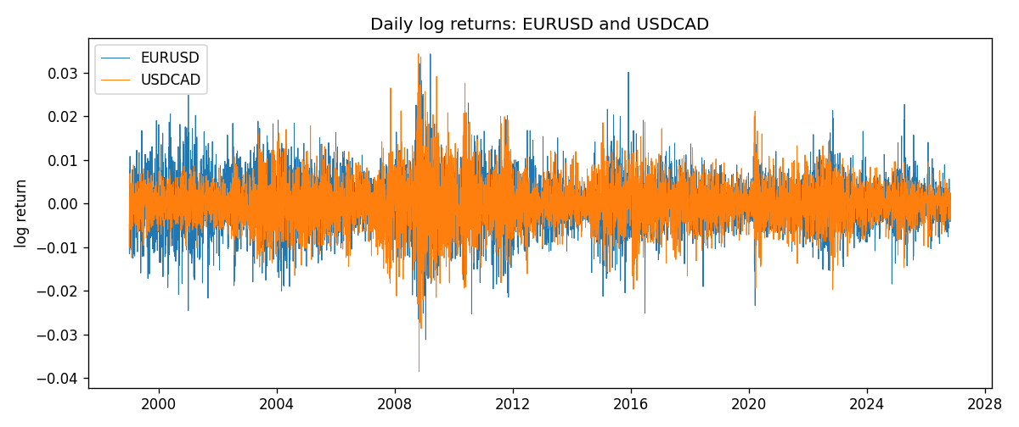
ADCC rho path with nested DCC and Pearson r
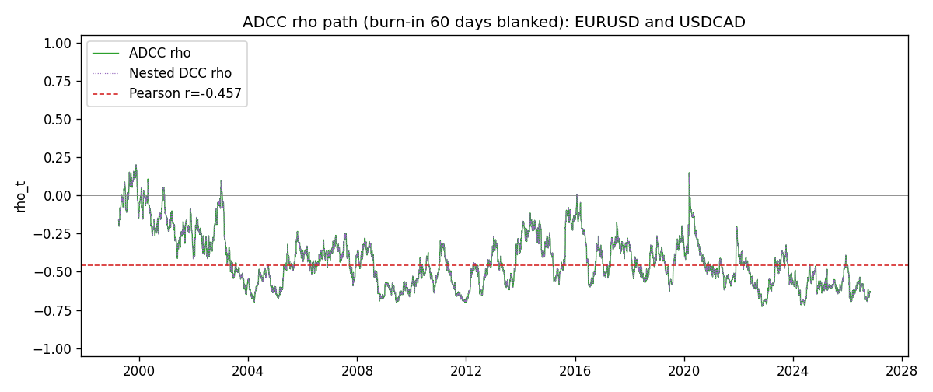

Data report
Every matched row that entered the ADCC recursion is stored in the sibling Excel workbook named EURUSD-USDCAD_ADCC_D1.xlsx. Embedding all rows as a Word table is impractical at this length; the Word file holds the column list, column summaries, and the first and last 15 matched rows.
Columns: time, EURUSD_open, USDCAD_open, EURUSD_high, USDCAD_high, EURUSD_low, USDCAD_low, EURUSD_close, USDCAD_close, EURUSD_tick_volume, USDCAD_tick_volume, EURUSD_spread, USDCAD_spread, EURUSD_real_volume, USDCAD_real_volume, EURUSD_log_return, USDCAD_log_return, EURUSD_sigma, USDCAD_sigma, EURUSD_z, USDCAD_z, EURUSD_n, USDCAD_n, q11, q22, q12, rho_adcc, rho_dcc
Column summaries (matched calculation rows)
column | count | mean | std | min | 25% | 50% | 75% | max
EURUSD_open | 7188 | 1.1814345 | 0.15078289 | 0.8272 | 1.086195 | 1.16617 | 1.2939425 | 1.5995
USDCAD_open | 7188 | 1.2667783 | 0.16890181 | 0.9168 | 1.1183975 | 1.298465 | 1.37211 | 1.6183
EURUSD_high | 7188 | 1.1865652 | 0.15138546 | 0.8326 | 1.0902775 | 1.17128 | 1.2993025 | 1.6038
USDCAD_high | 7188 | 1.2716763 | 0.16885945 | 0.9336 | 1.12285 | 1.30387 | 1.37649 | 1.619
EURUSD_low | 7188 | 1.1764236 | 0.15010221 | 0.8227 | 1.0820675 | 1.16257 | 1.2883725 | 1.5865
USDCAD_low | 7188 | 1.26222 | 0.16893673 | 0.9056 | 1.114065 | 1.293535 | 1.367805 | 1.6102
EURUSD_close | 7188 | 1.181473 | 0.1507571 | 0.8267 | 1.0860725 | 1.166175 | 1.2939575 | 1.5997
USDCAD_close | 7188 | 1.2667932 | 0.16887388 | 0.916 | 1.118295 | 1.29844 | 1.372365 | 1.6137
EURUSD_tick_volume | 7188 | 103177.84 | 173518.96 | 218 | 9407.75 | 52764 | 99553.25 | 1471626
USDCAD_tick_volume | 7188 | 81016.727 | 147303.02 | 37 | 5545 | 40941.5 | 71627 | 1410818
EURUSD_spread | 7188 | 19.349471 | 16.556644 | 0 | 8 | 12 | 30 | 50
USDCAD_spread | 7188 | 23.444073 | 18.266035 | 0 | 9 | 17 | 40 | 60
EURUSD_real_volume | 7188 | 4.031926e+10 | 1.6689501e+11 | 0 | 0 | 0 | 0 | 3.6149665e+12
USDCAD_real_volume | 7188 | 1.8376704e+10 | 9.6688094e+10 | 0 | 0 | 0 | 0 | 2.5751613e+12
EURUSD_log_return | 7188 | -7.59e-06 | 0.00580128 | -0.03123819 | -0.0032472 | 0 | 0.00325412 | 0.03433183
USDCAD_log_return | 7188 | -1.518e-05 | 0.00514306 | -0.03859748 | -0.00283637 | 4.741e-05 | 0.00272353 | 0.03436319
EURUSD_sigma | 7188 | 0.00556718 | 0.00169853 | 0.00258113 | 0.00432465 | 0.00538034 | 0.00650004 | 0.0145923
USDCAD_sigma | 7188 | 0.00479354 | 0.00181431 | 0.00250987 | 0.00365307 | 0.00435879 | 0.00535078 | 0.01852804
EURUSD_z | 7188 | -0.00306762 | 1.0000308 | -5.7779382 | -0.62093401 | -0.0013085 | 0.60994165 | 5.208067
USDCAD_z | 7188 | 0.00136894 | 1.0000942 | -4.0706189 | -0.62969178 | 0.01079697 | 0.6114507 | 6.4148564
EURUSD_n | 7188 | -0.38703872 | 0.59345081 | -5.7779382 | -0.62093401 | -0.0013085 | 0 | 0
USDCAD_n | 7188 | -0.3870216 | 0.58825089 | -4.0706189 | -0.62969178 | 0 | 0 | 0
q11 | 7188 | 1.0009313 | 0.16152686 | 0.6074631 | 0.89032016 | 0.98804789 | 1.0948813 | 1.8473074
q22 | 7188 | 1.0012477 | 0.16059188 | 0.65183329 | 0.89838682 | 0.97830145 | 1.0746847 | 2.0451921
q12 | 7188 | -0.42415273 | 0.19784028 | -1.2028299 | -0.55353268 | -0.43777247 | -0.30278331 | 0.23045546
rho_adcc | 7188 | -0.42297848 | 0.1779466 | -0.72751398 | -0.56308743 | -0.45466605 | -0.31889535 | 0.19996943
rho_dcc | 7188 | -0.42297848 | 0.17794658 | -0.72751398 | -0.56308739 | -0.45466608 | -0.31889544 | 0.19996935
First 15 matched rows (selected columns)
time | EURUSD_log_return | USDCAD_log_return | EURUSD_z | USDCAD_z | EURUSD_n | USDCAD_n | q11 | q22 | q12 | rho_adcc | rho_dcc
1999-01-05 | -0.0048360507 | -0.010131666 | -0.73642735 | -2.2375938 | -0.73642735 | -2.2375938 | 1 | 1 | -0.42461909 | -0.42461909 | -0.42461909
1999-01-06 | -0.011547966 | -0.0003306769 | -1.7723909 | -0.065877717 | -1.7723909 | -0.065877717 | 0.99067873 | 1.0816054 | -0.38241048 | -0.36942727 | -0.36942732
1999-01-07 | 0.0076280636 | 0.0015202092 | 1.1255931 | 0.31831837 | 0 | 0 | 1.0345132 | 1.0593826 | -0.37239023 | -0.35571636 | -0.35571641
1999-01-08 | -0.010902799 | -0.0020495197 | -1.6043964 | -0.43405645 | -1.6043964 | -0.43405645 | 1.0391279 | 1.0396646 | -0.3576895 | -0.34413201 | -0.34413206
1999-01-11 | -0.007103287 | -0.0035137769 | -1.0170558 | -0.75865915 | -1.0170558 | -0.75865915 | 1.0702543 | 1.02219 | -0.3364531 | -0.32167346 | -0.32167353
1999-01-12 | 0.0045103728 | 0.0066194721 | 0.6438558 | 1.4467823 | 0 | 0 | 1.0692808 | 1.0130169 | -0.31419118 | -0.30188376 | -0.30188384
1999-01-13 | 0.010845346 | 0.0045420214 | 1.56746 | 0.96993632 | 0 | 0 | 1.0557063 | 1.034971 | -0.28920272 | -0.27667297 | -0.27667305
1999-01-14 | 0 | 0.0069376546 | -0.001107953 | 1.4821794 | -0.001107953 | 0 | 1.0840515 | 1.0329315 | -0.25281754 | -0.23891668 | -0.23891677
1999-01-15 | -0.010153245 | -0.0056905671 | -1.4602244 | -1.1820134 | -1.4602244 | -1.1820134 | 1.0616821 | 1.0565226 | -0.24829688 | -0.23444157 | -0.23444166
1999-01-18 | 0.0036256946 | 0.00098344542 | 0.50963483 | 0.20429279 | 0 | 0 | 1.0832724 | 1.0632644 | -0.20869768 | -0.19445904 | -0.19445916
1999-01-19 | -0.00017235436 | 0.002748513 | -0.025752383 | 0.58042904 | -0.025752383 | 0 | 1.0662112 | 1.0422403 | -0.20307447 | -0.19264146 | -0.19264157
1999-01-20 | -0.0031939256 | -0.0059646885 | -0.46640563 | -1.2729606 | -0.46640563 | -1.2729606 | 1.0442804 | 1.0277286 | -0.20001014 | -0.1930653 | -0.19306541
1999-01-21 | 0.0030215416 | -0.0042823796 | 0.44565496 | -0.9010838 | 0 | -0.9010838 | 1.0272891 | 1.0397039 | -0.18462244 | -0.17864189 | -0.17864201
1999-01-22 | -0.0012075213 | 0.0025057712 | -0.18250826 | 0.53180938 | -0.18250826 | 0 | 1.0103172 | 1.0349279 | -0.18987204 | -0.18568512 | -0.18568523
1999-01-25 | -0.0030251979 | 0.00085579808 | -0.46394575 | 0.18554912 | -0.46394575 | 0 | 0.99038315 | 1.0194891 | -0.18879466 | -0.18788702 | -0.18788713
Last 15 matched rows (selected columns)
time | EURUSD_log_return | USDCAD_log_return | EURUSD_z | USDCAD_z | EURUSD_n | USDCAD_n | q11 | q22 | q12 | rho_adcc | rho_dcc
2026-10-13 | 0.0037402957 | -0.0046395653 | 1.0803661 | -1.6044001 | 0 | -1.6044001 | 0.89506005 | 0.81806801 | -0.54948737 | -0.64215065 | -0.64215063
2026-10-14 | -0.0037582255 | 0.0015184751 | -1.08333 | 0.50885939 | -1.08333 | 0 | 0.90096581 | 0.85446237 | -0.57316598 | -0.65325055 | -0.65325053
2026-10-15 | 0.0056053107 | -0.0036101503 | 1.6000303 | -1.215826 | 0 | -1.215826 | 0.90686146 | 0.84283755 | -0.5722055 | -0.65449994 | -0.65449993
2026-10-16 | 0.0017724895 | -0.0034322068 | 0.48912054 | -1.1387665 | 0 | -1.1387665 | 0.94085472 | 0.85632261 | -0.59966085 | -0.66807574 | -0.66807573
2026-10-19 | -0.0025394633 | -0.0018835331 | -0.71410483 | -0.61714615 | -0.71410483 | -0.61714615 | 0.92677002 | 0.86579094 | -0.59818573 | -0.66779558 | -0.66779557
2026-10-20 | 0.0023881672 | -0.0037066008 | 0.6714007 | -1.228306 | 0 | -1.228306 | 0.91853432 | 0.8563795 | -0.57642601 | -0.64992425 | -0.64992425
2026-10-21 | -0.00032046717 | -0.00084691787 | -0.093278152 | -0.27453339 | -0.093278152 | -0.27453339 | 0.90928984 | 0.8701631 | -0.58095652 | -0.65311872 | -0.65311872
2026-10-22 | -0.0015949606 | -0.0026307268 | -0.46244981 | -0.87198281 | -0.46244981 | -0.87198281 | 0.89126204 | 0.85442546 | -0.56806151 | -0.6509619 | -0.65096189
2026-10-23 | -0.001338521 | 2.85545e-05 | -0.39292128 | 0.011970262 | -0.39292128 | 0 | 0.87784222 | 0.85301365 | -0.54778254 | -0.63302661 | -0.63302661
2026-10-26 | -0.0022706559 | 5.7106554e-05 | -0.67326249 | 0.021853768 | -0.67326249 | 0 | 0.86353093 | 0.83615259 | -0.53629538 | -0.63113511 | -0.63113511
2026-10-27 | -0.004152342 | 0.0025379458 | -1.2375241 | 0.87718719 | -1.2375241 | 0 | 0.85564814 | 0.81970012 | -0.52528583 | -0.62722098 | -0.62722098
2026-10-28 | 0.0022262927 | -0.0038379274 | 0.65134076 | -1.3202424 | 0 | -1.3202424 | 0.86991211 | 0.8193012 | -0.5363477 | -0.63531183 | -0.63531183
2026-10-29 | 0.0022571351 | -0.00011436495 | 0.6652346 | -0.036102634 | 0 | -0.036102634 | 0.86128586 | 0.83874033 | -0.54255102 | -0.63834162 | -0.63834162
2026-10-30 | -0.0011458446 | -0.0010298736 | -0.34357097 | -0.35128106 | -0.34357097 | -0.35128106 | 0.85323773 | 0.82224302 | -0.53158187 | -0.6346511 | -0.6346511
2026-11-02 | 0.002120569 | 0.00061519094 | 0.63732863 | 0.21703657 | 0 | 0 | 0.8387725 | 0.80862549 | -0.51792694 | -0.62888711 | -0.62888711

